

**Services and Solutions Streamlined**

**One Stop Solution for Property / Facility Management Services.**

**User Manual**

**Table of Content**

|  |  |  |
| --- | --- | --- |
| S. No. | Module | Page No. |
| 1 | Multi Property Management | 2 - 10 |
| 2 | Visitor Management | 11-12 |
| 3 | Complaint Management / Helpdesk | 12 |
| 4 | Communication Management | 13 |
| 5 | Report (Invoice) | 13 |

**Multi Property Management**

**Single Dashboard**

S3 App uses simple toggle from one property to the next. Select one and use all the App features activated for that community.

**Tag Rented Properties**

If resident rent out any of the properties, he will continue to receive Community updates. However, visitors, daily help and deliveries will only be visible to the tenant.

The Process of accessing the S3 App features the process is as follows:

**SUPER ADMIN**

**STEP-1** Super Admin shall login into the account by providing a predefined mobile number and OTP.

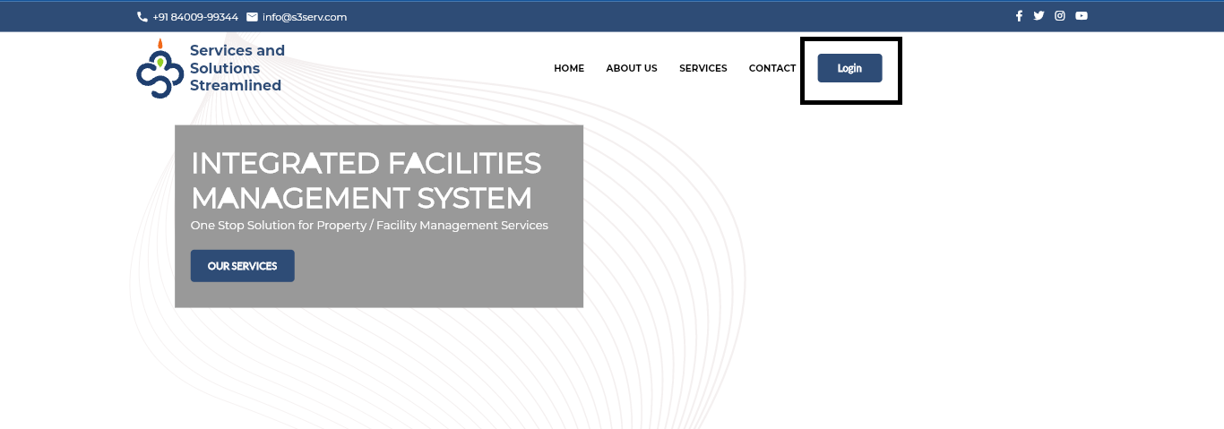

**STEP-2** Super Admin shall fill mobile number and press the send OTP button and get an OTP into entered mobile number, after entering that OTP Super Admin can login.

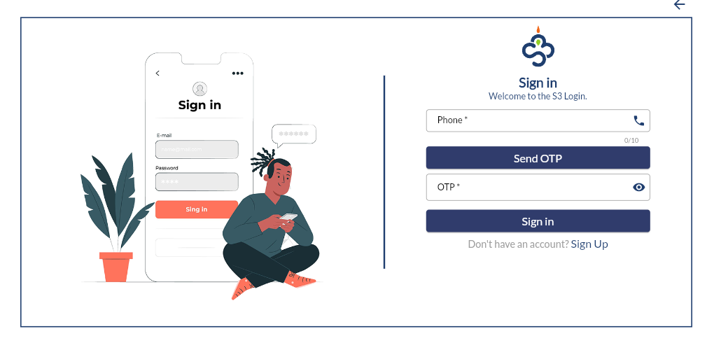

**STEP-3** Super Admin Dashboard

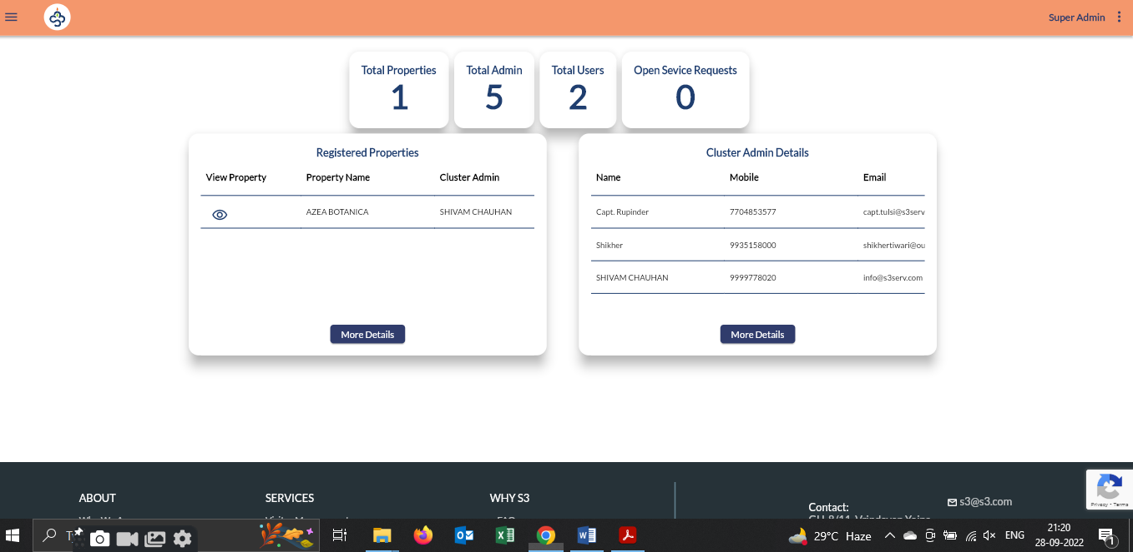

**STEP-4** Super Admin can view or add/edit new/existing multiple properties under more details > property Management Page.

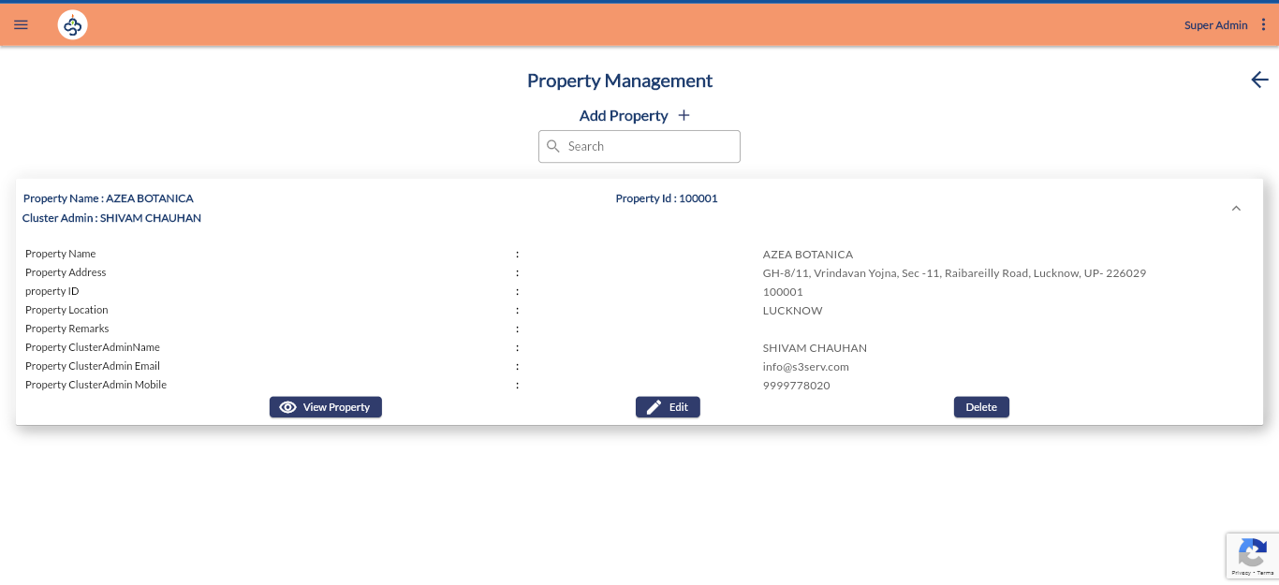

Super Admin can add multiple properties using Add Property option. Before adding a property Super Admin shall add a cluster admin that will manage the allotted property under super admin.

**STEP-1**

To add a cluster admin Super Admin will choose the **Cluster Admin Management** option.

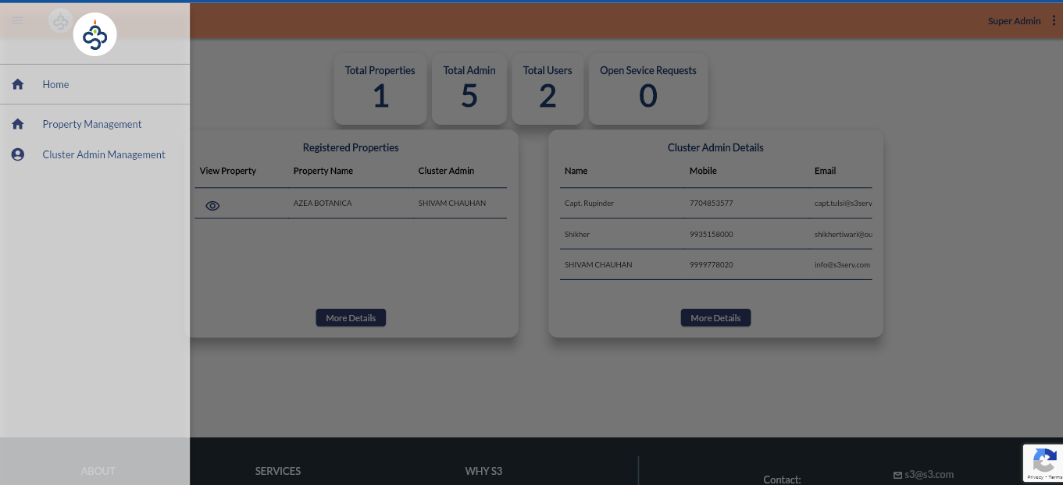

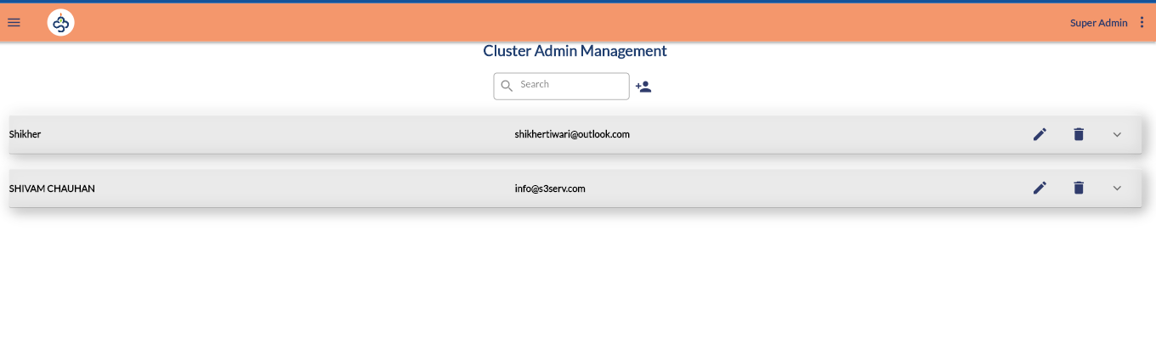**STEP-2** Super Admin will choose the **Add Cluster Admin option.**

**STEP-3** Super Admin will fill the Registration form and submit**.**

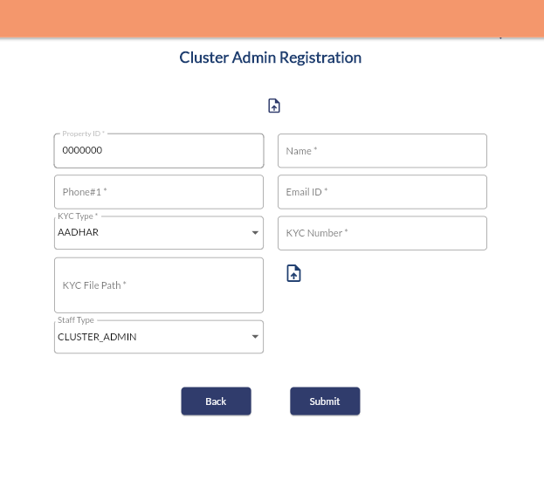

Super Admin will add property, after Adding a cluster admin.

**STEP-1** Super Admin choose **Add property** option



**STEP-2** Super Admin will fill in all the details related to the property and choose the cluster admin for it. Super Admin will also add a check to the service used by the property.

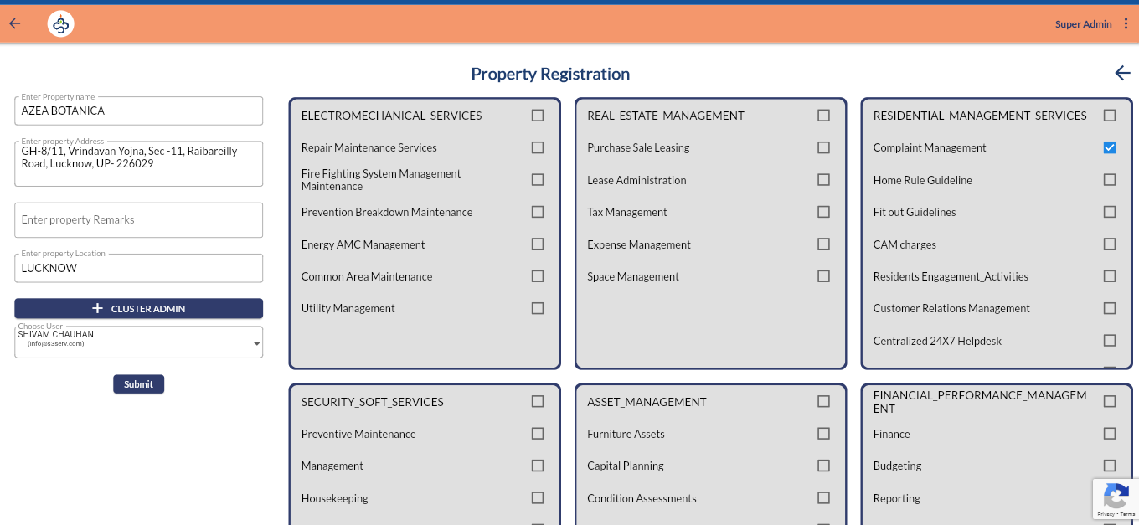

After Submit property will be created and cluster admin assigned to it.

Super Admin will add Block and Unit for property under

1. view property > Manage Property Block
2. view property > Manage Property Unit

Super Admin can upload bulk units using excel CVV file, available in under Manage Property Unit.

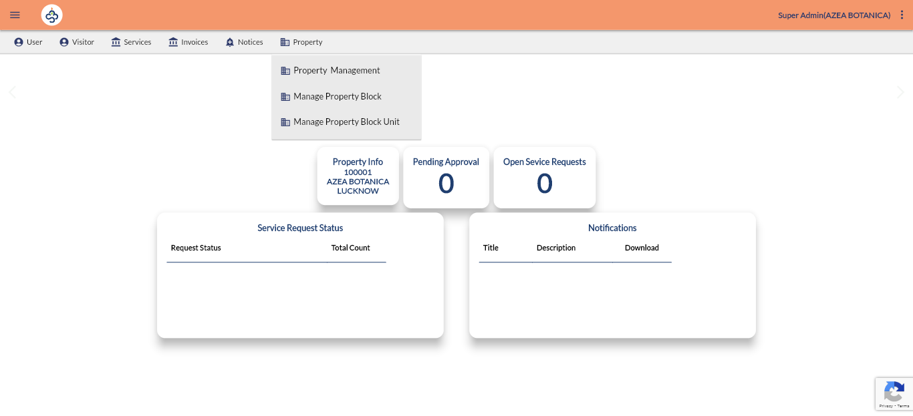

**STEP-1** Add Property Block

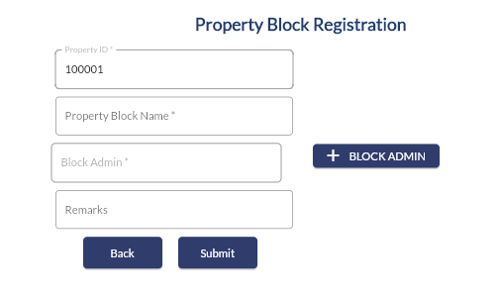

**STEP-2** Add Property Unit

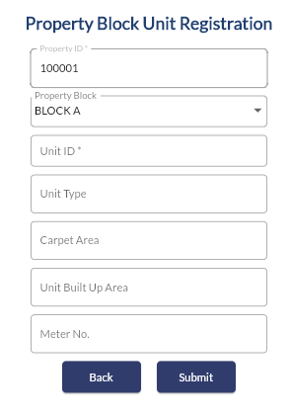

After Adding Property Profile, Super Admin will give permission to the cluster-admin.

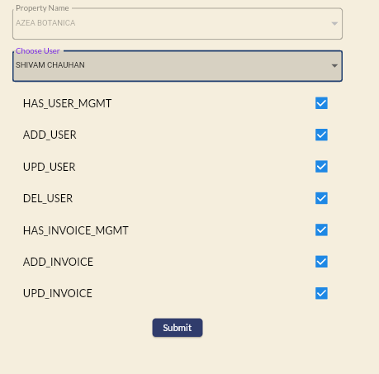View property > Users > Admin Permissions

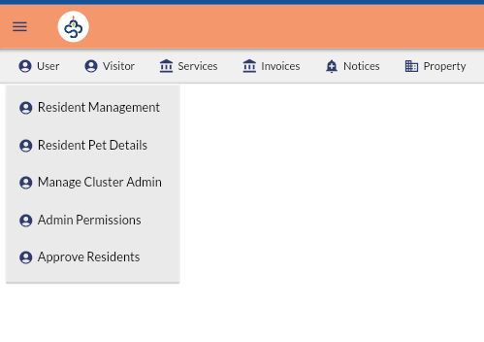

|  |  |
| --- | --- |
| **Permission** | **Description** |
| HAS_USER_MGMT | User can access user management under his Login. |
| ADD_USER | User can add user profile under his Login. |
| UPD_USER | User can update user profile under his Login. |
| DEL_USER | User can delete user profile under his Login. |
| HAS_INVOICE_MGMT | User can access invoice management feature. |
| ADD_INVOICE | User can add invoice. |
| UPD_INVOICE | User can update invoice. |
| DEL_INVOICE | User can delete invoice. |
| HAS_VISITOR_MGMT | User can access visitor management feature. |
| ADD_VISITOR | User can add visitor. |
| UPDATE_VISITOR | User can update visitor. |
| DEL_VISITOR | User can delete visitor. |
| HAS_SERVICE_MGMT | User can access Service Management feature. |
| ADD_SERVICE_REQUEST | User can add service request. |
| UPD_SERVICE_REQUEST | User can update service request. |
| DEL_SERVICE_REQUEST | User can delete service request. |
| HAS_NOTICE_MGMT | User can access Notice Management feature. |
| ADD_NOTIFICATIONS | User can add notifications. |
| UPD_NOTIFICATIONS | User can update notifications. |
| DEL_NOTIFICATIONS | User can delete notifications. |
| HAS_PROPERTY_MGMT | User can access Property Management feature. |
| ADD_PROPERTY | User can add property. |
| UPD_PROPERTY | User can update property. |
| DEL_PROPERTY | User can delete property. |
| CHANGE_USER_PERMISSION | User can change another user's permission under his Login. |
| ADD_ADMIN | User can Add another admin |
| IS_ADMIN | To be implemented if required. |

**CLUSTER ADMIN**

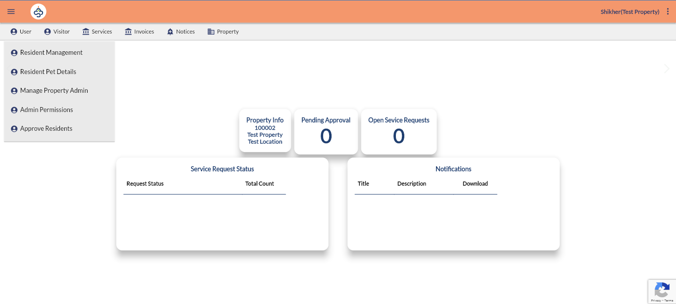After getting permissions from Super Admin, Cluster admin will be able to login with registered mobile number and OTP. After Login Cluster admin will add property admin of particular property. View property > User > Manage Property Admin. Cluster Admin can give permission to property admin using Admin Permission option.

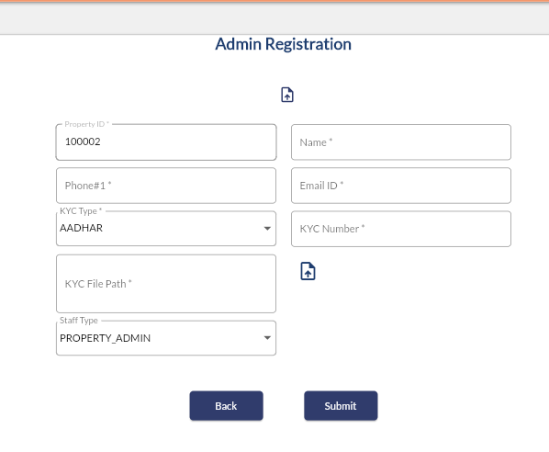

**PROPERTY ADMIN**

After getting permissions from Cluster Admin, Property admin will be able to login with registered mobile number and OTP. After Login Property Admin will add Security, Block Admin, Helpdesk accounts of particular property. User > Staff Management.

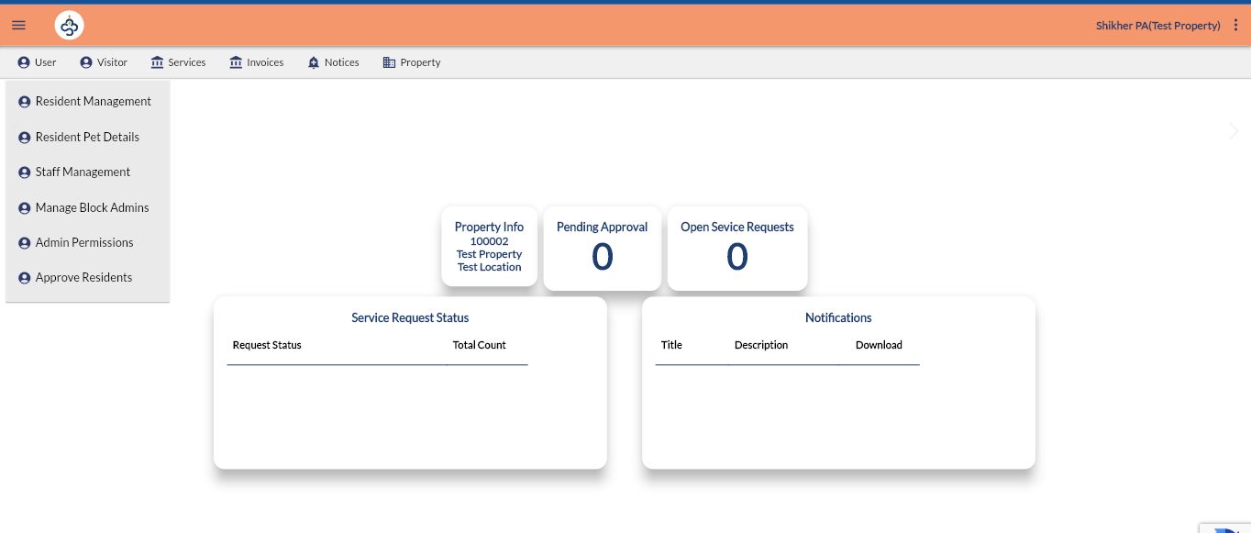

**BLOCK ADMIN**

Block Admin will be responsible for a particular block of the property.

**SECURITY**

Security will be responsible for visitor management.

**Helpdesk**

Helpdesk will be responsible for service request management.

**RESIDENT**

Any resident who wants to register with S3 app will choose the Login option first. In Next screen he will choose **Signup** option.

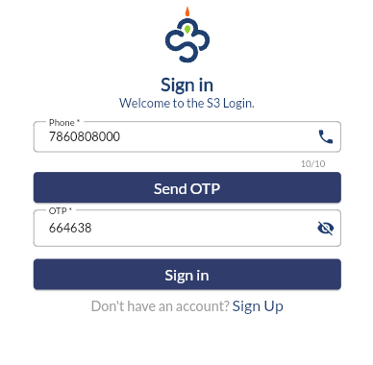

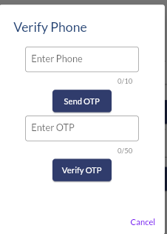After choosing Signup option resident will verify his phone number using OTP.

After verifying the phone number, a registration form will be open.

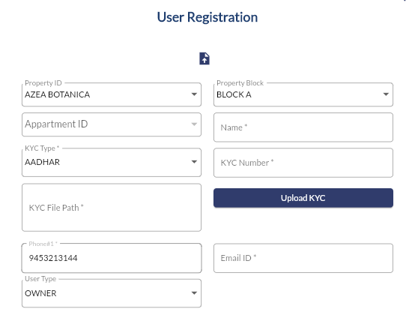

The resident will select the property name first, and after that, he will select the property block and apartment ID. The resident will fill out the form and submit it to the property admin. After getting approval from the property admin, the resident will be able to login with a registered mobile number and OTP.

**VISITOR MANAGEMENT**

**Use pass code invites**

Replace the intercom and register book for a technologically-forward pass code-based solution that makes it easy for residents to participate in the process of approving their visitors.

**Verify unexpected visitors**

The process is also simplified for visitors that simply turn up at the gate. Residents receive a notification on their app, requesting them to approve their entry. One click and they’re in.

**Resolve parking issues**

A visitor’s car is in a resident's spot? Fix this with ease on app, simply enter the vehicle number and get the owner’s contact details. Resolve the issue quickly.

When a visitor will come to the gate of community, Security will check his approval by entering token into the system in case of the preapproved guest. If guest is not preapproved then security will fill the following form and request to resident for entry, in the same time resident will get an alert message regarding the visitor. After getting approval from the resident, security will allow visitor to enter.

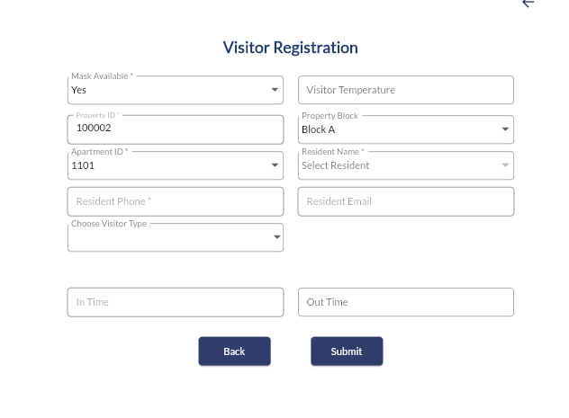

**Search Pre-Approved Visitor by Token**

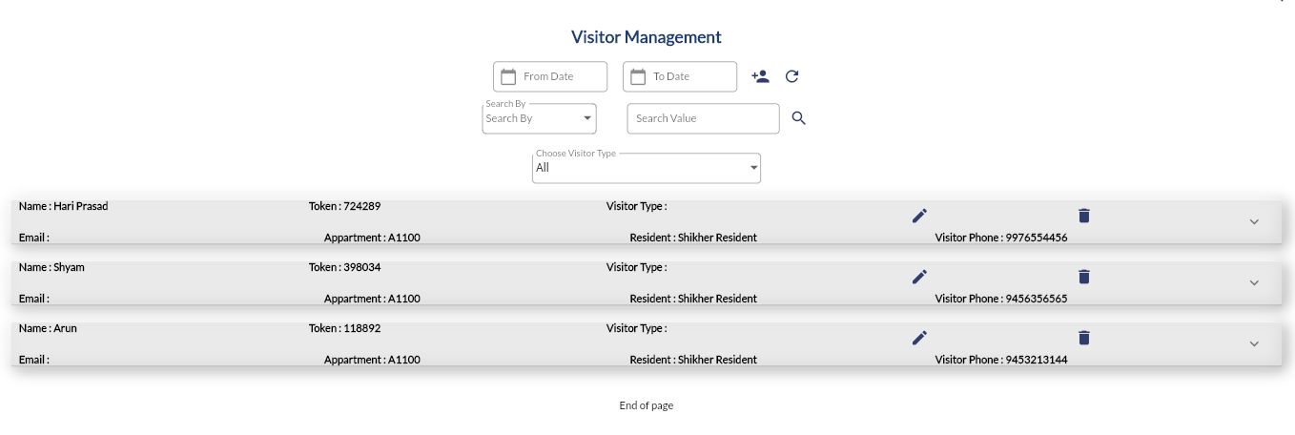

**Pre-Approve Visitor (Resident)**

Resident can preapprove visitors, he will select the visitor type and after filing following form a token will be generated and same will be visible to the security guard also. Security guard will allow the visitor on basis of that token.

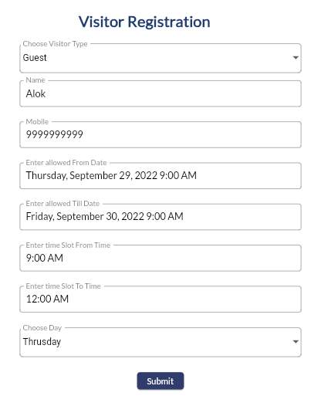

**Service Request / Helpdesk**

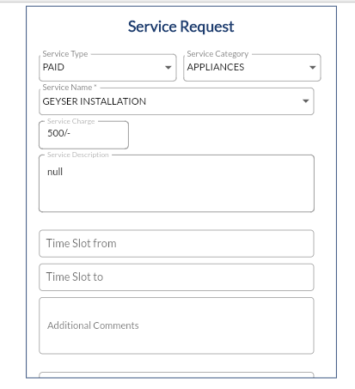Resident can raise a complaint/ Service request to the helpdesk, and helpdesk will assign a technician for this. After successfully completion of request invoice will also be available into resident login

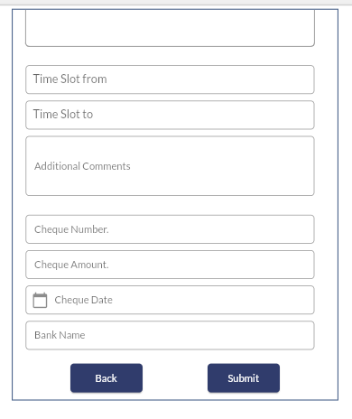

**Report (Invoice)**

Resident can get their invoices from Invoices option.

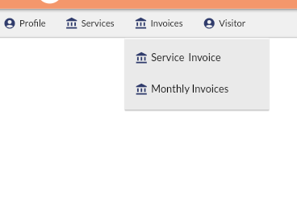

**Communication Management**

**Notice Boards/Announcements**

Resident can see all announcements/Notice through the app.

